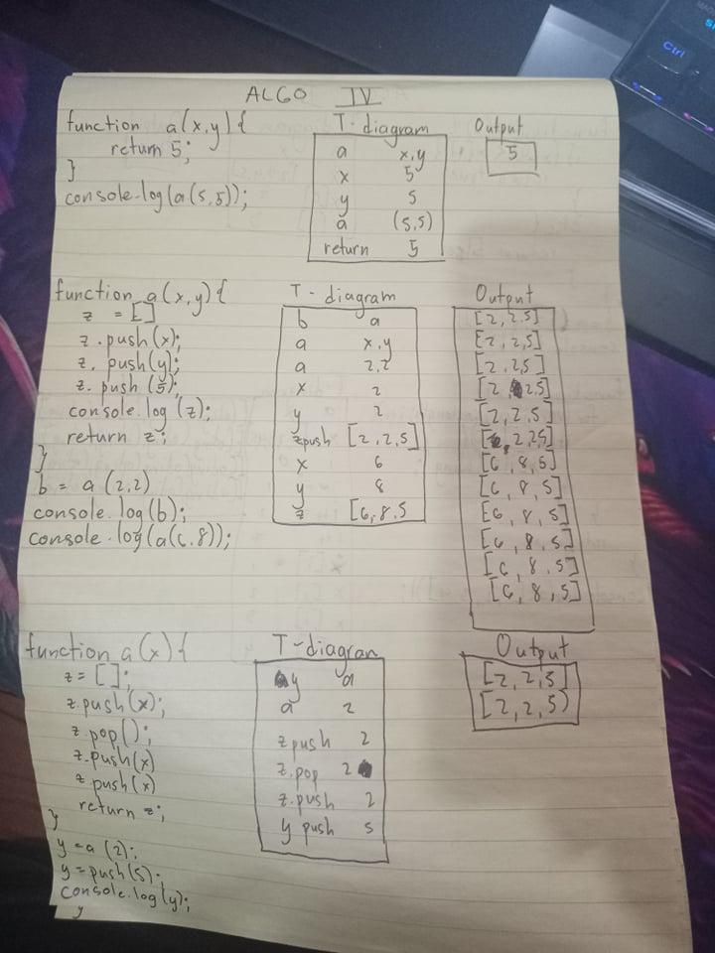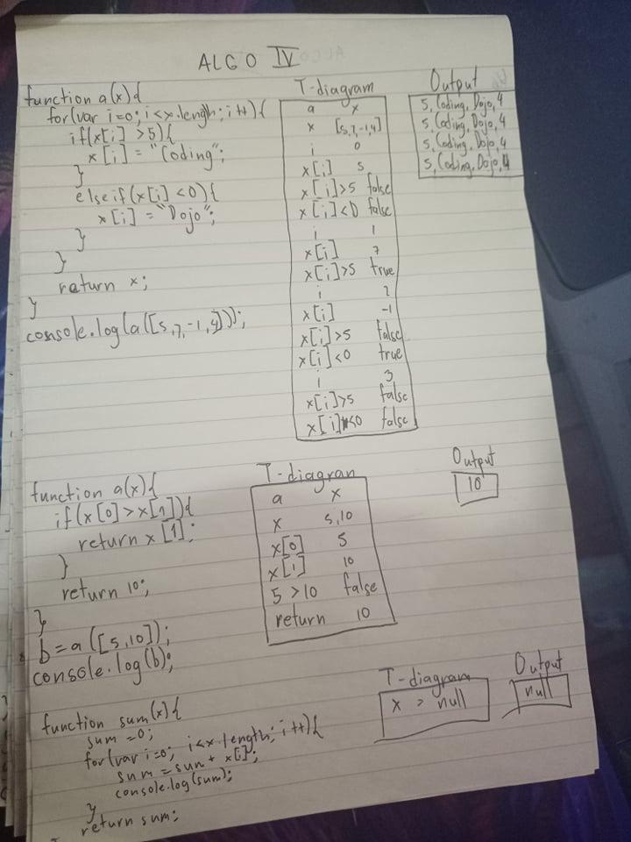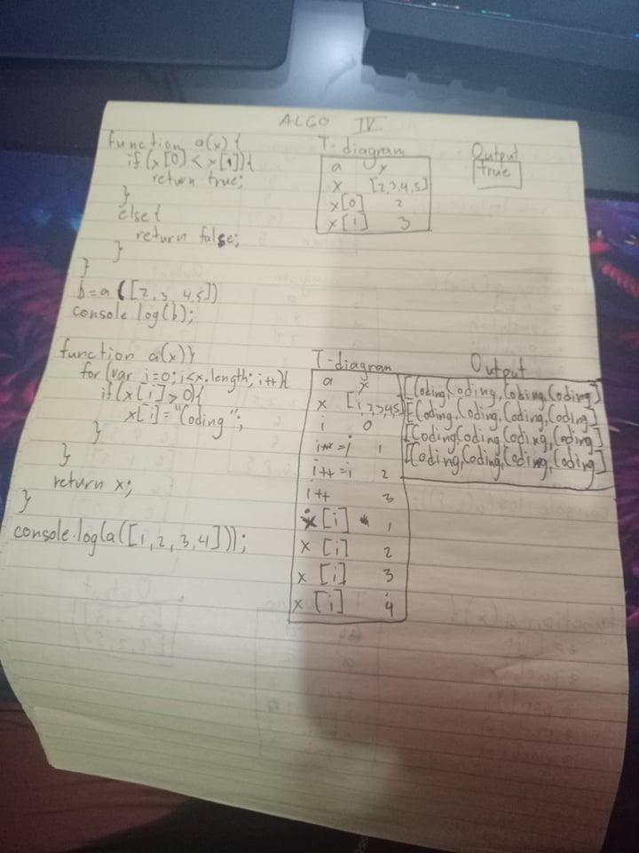Algo 4 part 2

function printAverage(x){

sum = 0;

for (var i = 0; i<x.length; i++){

sum += x[i]

}

var avg = sum /x.length;

return avg;

// your code here

}

y = printAverage([1,2,3]);

console.log(y); // should log 2

y = printAverage([2,5,8]);

console.log(y); // should log 5

function returnOddArray(){

// your code here

x = [];

for (var i = 0; i<=255; i++){

if (i%2 !== 0){

x.push(i)

}

}

return x;

}

y = returnOddArray();

console.log(y); // should log [1,3,5,...,253,255]

function squareValue(x){

// your code here

for (var i = 0; i<x.length ; i++){

x[i] = x[i] \* x[i]

}

return x;

}

y = squareValue([1,2,3]);

console.log(y); // should log [1,4,9]

y = squareValue([2,5,8]);

console.log(y); // should log [4,25,64]